**AWS SNS SERVICE**

**🡪**create a topic

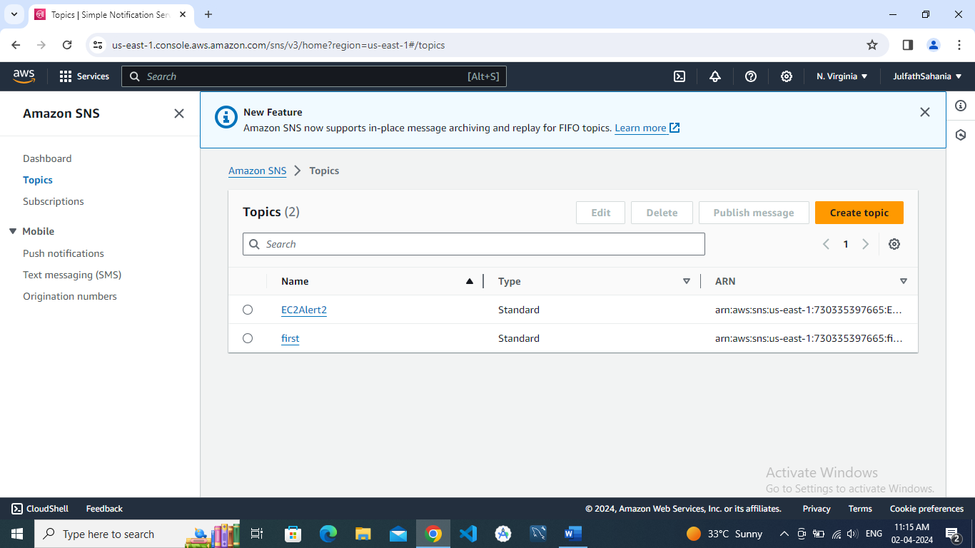

🡪Create subscription

🡪Add the protocol

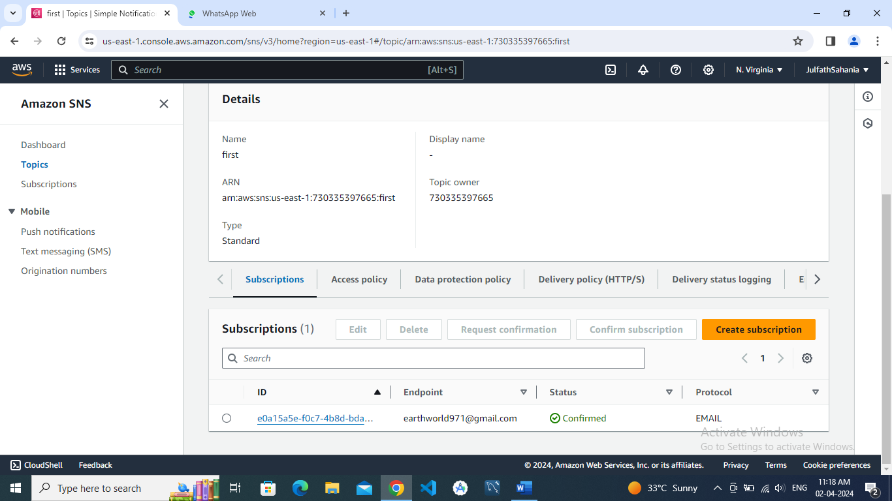

🡪receive message in email

